TABLE OF CONTENTS

Chapter  No. | Title | Page No
 | ABSTRACT | (i)
1  1.1  1.2  1.3  1.4  1.5 | INTRODUCTION  General Introduction  Existing System  Proposed System  Methodology  Feasibility Study | 1-4
2  2.1 | REVIEW OF LITERATURE  Review – Summary | 5
3  3.1  3.2 | SYSTEM CONFIGURATION  Hardware requirements  Software requirements | 6
4  4.1 | MODULE DESCRIPTION  Modules | 7
5  5.1  5.2 | SYSTEM DESIGN  Data Flow Diagrams  Use Case Diagram | 8-11
6  6.1  6.2 | SYSTEM IMPLEMENTATION  Implementation  Screenshots | 12-17
7  7.1  7.2  7.3 | SYSTEM TESTING  Test cases  Unit Testing  Validation Testing | 18-21
8  8.1  8.2 | RESULT AND DISCUSSION  Conclusion  Future Enhancement | 22-23

9  9.1  9.2 | REFERENCES  Text reference  Web reference | 24
10 | SIMILARITY INDEX | 25

LIST OF FIGURES

Sl.  No. | Figure No | Title | Page No.
1. | 5.1 | Data Flow Basic Notation | 10
2. | 5.2 | Data Flow Diagram( Zero level DFD) | 10
5. | 5.3 | Use case diagram | 11
6. | 5.4 | E R diagram | 12
7. | 6.1 | Home page | 16
8. | 6.2 | Product page | 16
9. | 6.3 | House hold page | 17
11 | 6.4 | Contract manufacturing | 17
12 | 6.5 | Contact us | 18
13 | 6.6 | Write to us | 18
22 | 7.1 | Test cases type | 19

ABSTRACT

The E Career Guidance is a carefully designed web application to enhance the job process by creating an interactive and user-friendly experience for candidates. The application was created with a unique approach to manage job seekers and company updates, develop customer and competitive information based on business needs and employees. The portal's online accessibility provides detailed information on career opportunities, providing employers with a central hub where they can post job details and candidates, work capacity. As authorized users, registered employers can post job vacancies, search a library of potential candidates, and refine their searches accordingly. The miracle given by staff upon registration, the platform not only improves the recruitment process, but also allows employers to make informed decisions by obtaining detailed information about candidates' competitors and skills. Career services act as a bridge that connects employers with qualified candidates in a structured and efficient manner, ultimately helping to increase productivity and improve hiring. Additionally, the service portal serves as an important user experience and transparency tool. After registration, job seekers can use the platform to highlight their skills and qualifications by creating detailed profiles that will attract the attention of employers. The intuitive design of the portal ensures that candidates receive timely updates on job postings that match their skills. Seamless integration of the job application process allows candidates to easily apply to multiple jobs, ensuring efficient and effective work. Additionally, the portal's search capabilities allow employers to find candidates based on specific skills, making it easier to acquire the right skills. The platform's current approach increases efficiency and speed by ensuring that job postings and candidate information are always up to date. Employment Portal Services is a proven technology for today's recruitment that combines cutting-edge technology with user-centered design to create a platform that meets the changing needs of employers. Recruiting and hiring in today's competitive business.

CHAPTER 1
INTRODUCTION

  - General Introduction
In an environment of weak job creation, E Career Guidance appears to be a game changer, bridging the gap between professionals and opportunities. This comprehensive training, created using Spring Boot and React JS, aims to modernize the job search environment. E Career Guidance integrates a user-centered approach that allows job seekers to share their skills and employers to advertise and search for more jobs. Committed to transparency, efficiency and modern technology, the platform streamlines information and facilitates hiring. As a versatile solution, E Career Guidance acts not only as a job portal but also as a knowledge base and community base. Its innovative features are designed to empower employers and job seekers in today's competitive business environment, encouraging collaboration and informed decision-making.

  - Objective of the Project
The primary objective of the E Career GuidanceSystem is to create a comprehensive platform that facilitates efficient job-seeking and hiring processes. The system aims to provide members with essential job information, enabling online job applications and offering various functionalities for a seamless user experience. The central focus is on establishing direct connections between job providers and candidates, fostering personalized interactions. The project strives to streamline the posting and management of job vacancies, ultimately transitioning all job postings to an online format. This transition empowers employers to effortlessly post vacancies, while the system ensures an effective and organized review of incoming job applications through the web interface. Additionally, the project aims to expedite the recruitment process by allowing employers to swiftly find resumes based on key skills, promoting a time-efficient and tailored hiring experience.

  - Existing System
The existing system for E Career Guidance involves traditional methods of job seeking and recruitment, which are often manual, time-consuming, and less streamlined. Job seekers typically rely on various sources like newspaper advertisements, physical job fairs, and company websites to discover employment opportunities. The application process is often paper-based or requires physical submission of resumes. Similarly, employers follow conventional methods to announce job vacancies, involving physical job postings, newspaper advertisements, or relying on recruitment agencies. The recruitment process is primarily offline, making it challenging for employers to efficiently manage and track job applications. The lack of a centralized platform results in limited accessibility to a diverse pool of candidates. Overall, the existing system lacks the efficiency, speed, and convenience that a modern E Career Guidancecan offer. E Career Guidance aims to address these limitations by introducing a comprehensive and user-friendly online platform, enhancing the overall job seeking and recruitment experience for both employers and job seekers.

  - Proposed System
The proposed E Career Guidance system envisions a paradigm shift in the traditional job-seeking and recruitment landscape, introducing a dynamic online portal powered by cutting-edge technologies like Spring Boot and React JS. For job seekers, the system offers a modern platform to create comprehensive profiles, showcase skills, and seamlessly apply for diverse job opportunities, eliminating the complexities of traditional application processes. On the employer front, E Career Guidance provides a centralized hub for posting, managing, and tracking job vacancies. Employers can efficiently search for candidates based on key skills, streamlining recruitment. Real-time updates and a user-friendly dashboard enhance the employer experience, fostering informed decision-making. The proposed system aims to transcend the limitations of existing offline methods, ushering in a technologically advanced, transparent, and inclusive solution that reshapes the job portal landscape for optimal efficiency and collaboration.

  - Methodology Used
The methodology adopted for the E Career Guidance project is tailored to ensure optimal development efficiency and responsiveness to the evolving needs of the job portal system. The choice of methodology considers factors such as project complexity, team structure, and the dynamic nature of the recruitment landscape.

Agile Methodology:
E Career Guidance leverages the Agile methodology, emphasizing flexibility, collaboration, and iterative development. The project is broken down into manageable tasks or "user stories," prioritized based on their significance. Short iterations, known as "sprints," typically lasting 1-4 weeks, are undertaken, resulting in potentially shippable product increments. Agile methodologies, including Scrum or Kanban, facilitate adjustments and enhancements throughout the project based on continuous feedback.

Hybrid Methodology:
In certain project phases, E Career Guidance adopts a hybrid approach that combines elements of both Agile and Waterfall methodologies. Agile is employed during development for its flexibility and quick iterations, allowing for adjustments based on evolving requirements. Meanwhile, Waterfall principles are applied in planning and documentation stages to establish a clear scope and requirements.

Incremental Development:
The E Career Guidance project incorporates incremental development, breaking down the system into smaller parts for separate development. Each increment introduces new features or improvements, building upon the progress of the previous increment. This approach allows for continuous enhancement and refinement of the job portal system. By aligning the methodology with the specific demands of E Career Guidance, the project aims to deliver a responsive, user-centric, and feature-rich job portal that effectively addresses the needs of both job seekers and employers in today's competitive job market.

  - Feasibility Study
The feasibility study for the E Career Guidance project involves a comprehensive examination of technical, economic, operational, financial, and legal aspects to ascertain the viability and potential success of the proposed E Career Guidancesystem.

Technical Feasibility: The technical feasibility of E Career Guidance assesses the availability and capabilities of the required technologies, software, and infrastructure. Given the advancements in Spring Boot and React Js, the project is technically feasible, promising the development of a robust and scalable platform for efficient job seeking and recruitment.

Economic Feasibility: Economic feasibility examines the cost implications and potential returns on investment. It involves estimating development, implementation, maintenance costs, and comparing them to expected benefits. With the potential for increased market reach and improved efficiency in the job market, the economic feasibility of E Career Guidance is favorable, offering potential returns through enhanced user engagement.

Financial Feasibility: The financial feasibility entails estimating project costs, including development, implementation, and maintenance, and comparing these with potential revenue streams or cost savings resulting from the system. Calculating the return on investment (ROI) and payback period indicates a positive financial outlook for E Career Guidance, supported by the anticipated value it brings to employers and job seekers.

Operational Feasibility: Operational feasibility evaluates how well the proposed system aligns with existing processes and seamlessly integrates into daily operations. E Career Guidance addresses this aspect by providing user-friendly interfaces for both employers and job seekers, aligning with the operational needs of the recruitment process and enhancing overall feasibility.

Legal Feasibility: E Career Guidance's legal feasibility is assured by strict adherence to data privacy laws, user agreements, and regulatory requirements, fostering compliance and risk mitigation in its operations.

CHAPTER 2
REVIEW OF LITERATURE

2.1 Review Summary
Job procurement has undergone a transformative shift from traditional to contemporary methods. Previously reliant on channels like employment agencies and job fairs, the process was slow and lacked quality. Galanaki emphasizes the limitations and challenges associated with these traditional approaches. The internet's emergence as a powerful tool in job seeking has revolutionized the process. The E Career Guidance project aligns with this shift, recognizing the inefficiencies of traditional methods and aiming to provide a streamlined and efficient online job portal. In the current technological age, the internet plays a pivotal role in disseminating information to job seekers. Large corporations, institutions, and universities now include career prospects on their websites, reflecting the shift towards digital platforms. Job portals have become crucial in this landscape, offering a convenient and centralized hub for job seekers. According to surveys, a significant percentage of the workforce utilizes online portals to search for job opportunities, highlighting their importance in the contemporary job-seeking ecosystem. While the internet has significantly facilitated the job-seeking process, traditional methods have not been entirely replaced. There is a coexistence of both traditional and online approaches, with each having its own set of advantages and limitations. The E Career Guidance project acknowledges this dynamic landscape, aiming to integrate the strengths of online job portals while recognizing the value of certain traditional methods that continue to play a role in the recruitment process. The importance of job portals cannot be overstated in the era of technology. According to a survey, 70% of the workforce in India utilizes websites or portals on the internet for job searches, underlining their significance in the contemporary job-seeking landscape. These portals serve as comprehensive platforms, providing search engines that enable users to access a vast array of job opportunities.

CHAPTER 3
SYSTEM CONFIGURATION

3.1 Hardware Requirements

Processor : i5 Core Processor
Clock speed : 2.5GHz
Monitor : 1024 * 768 Resolution
Color Keyboard : QWERTY
RAM : 1 GB
Motherboard : 845c Intel Motherboard
Backup Media : Floppy/pen drive/Hard disk.
Hard disk : 1 TB HDD I/O
Device : Standard input and output devices.

3.2 Software Requirements

Operating System : Windows 10, 8, 11.
Backend Framework : Spring Boot(Java)
Frontend Framework : React JS
Database Management System : MySQL

CHAPTER 4
MODULES DESCRIPTION
4.1 Module
1. Administrator Module:
Overview: The Administrator module provides comprehensive control over the entire E Career Guidance system. It includes functionalities such as user management, system configuration, and overall system monitoring.
Key Features:
User Management: Create, modify, and manage user accounts with different roles.
System Configuration: Configure system settings, preferences, and parameters.
Monitoring: Oversee the entire system, track activities, and generate reports.

2. Employer Module:
Overview: The Employer module caters to organizations or individuals posting job opportunities on E Career Guidance. It facilitates the process of job posting, applicant management, and communication with potential employees.
Key Features:
Job Posting: Create and publish job openings with detailed descriptions.
Applicant Management: View, shortlist, and manage applications received for posted jobs.
Communication: Interact with potential employees and update job status.

3. Employee Module:
Overview: The Employee module is designed for individuals seeking job opportunities. It empowers users to create and manage their profiles, apply for jobs, and track application statuses.
Key Features:
Profile Management: Create and update personal profiles, including education, work experience, and skills.
Job Search: Browse and search for job opportunities based on various criteria.
Application Submission: Apply for jobs seamlessly and track application statuses.
CHAPTER 5
SYSTEM DESIGN
The system design of the E Career Guidance project is strategically crafted as a user-centric digital platform, encompassing key components to ensure efficiency and effectiveness across the entire job portal system.

1. Navigation and Responsiveness:
Core Focus: Ensures seamless navigation and responsiveness across various devices, enhancing the user experience.

2. Job Posting and Management System:
Database and Content Management: Incorporates a robust database and content management system for efficient job posting, management, and updates.

3. Applicant Tracking System:
Streamlined Application Process: Facilitates a user-friendly application process for job seekers, allowing them to track their application statuses.

4. Skills and Profile Management:
Personalized Profiles: Empowers users to create and manage comprehensive profiles, including education, work experience, and skills.

5. Real-time Job Recommendations:
Intelligent Matching: Utilizes algorithms to provide real-time job recommendations based on user profiles and preferences.

6. Dynamic Content Hub:
Blog, News, and Events: A dynamic content management system organizes and updates blogs, news, and events, transforming E Career Guidance into a continuously evolving knowledge hub.
5.1 Data Flow Diagram
A Data Flow Diagram serves as a vital graphical tool to visually represent and analyze the flow of data within a system. This diagram forms the foundational structure for developing other system components. It offers a logical illustration of data transformation, depicting how data moves from input to output through various processing stages. Logical DFDs abstractly describe the data flow, independent of the physical elements within the system.

Logical DFDs:
Logical DFDs focus on the logical flow of data, providing a conceptual understanding of how information is processed and transformed within the system. These diagrams play a crucial role in system analysis, helping analysts comprehend data movement and transformation.

Physical DFDs:
Physical DFDs, in contrast, depict the actual tools and data movement within the physical system. They illustrate how data is transferred between individuals, departments, and workstations, offering a more tangible representation of the system's components.

Context Diagram:
The context diagram, often referred to as the top-level diagram, is an essential starting point for understanding the current system. It comprises a single central process representing the entire system. This central process is then decomposed into a set of processes at the first level of the DFD. This decomposition continues, breaking down understanding into greater detail at each subsequent level. The iterative nature of this process allows analysts to achieve the desired level of detail, facilitating a comprehensive comprehension of the system's data flow and processes.

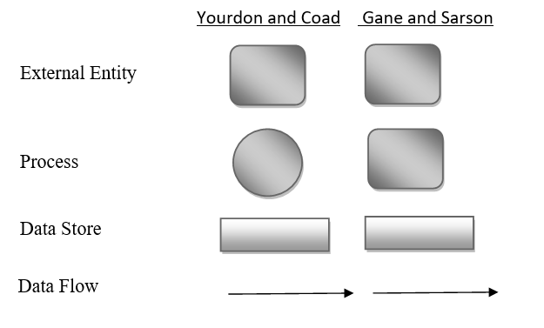
Fig 5.1: Data Flow Basic notations

Zero Level Data Flow Diagram
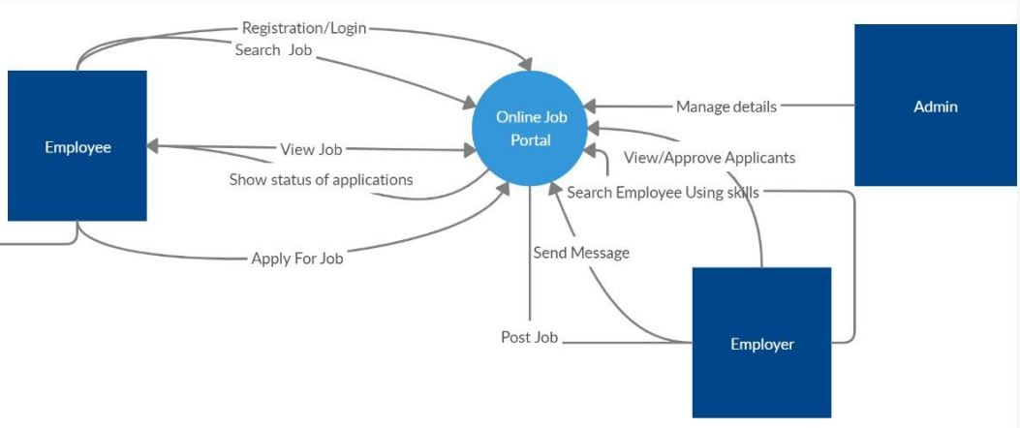
Fig 5.2: Zero level DFD
The Zero Level Data Flow Diagram (DFD) for E Career Guidance provides a succinct overview of the primary processes: Job Posting, Job Application, and User Authentication. Employers post jobs, Job Seekers apply, and User Authentication ensures secure logins. This foundation sets the stage for a more detailed exploration of the E Career Guidancesystem.

5.2 Use Case Diagram
Actor and use case description shows the detail description of interaction between the actors and their use cases. The description enables to have a proper understanding of how actor interacts with the system through their use cases,
Creating a use case diagram for a Rallis website project involves identifying key actors and their interactions with the system. Actors could include users, admins, and possibly external systems. Use cases might encompass actions like browsing products, placing orders, and managing inventory. The diagram helps visualize system functionalities and user interactions.

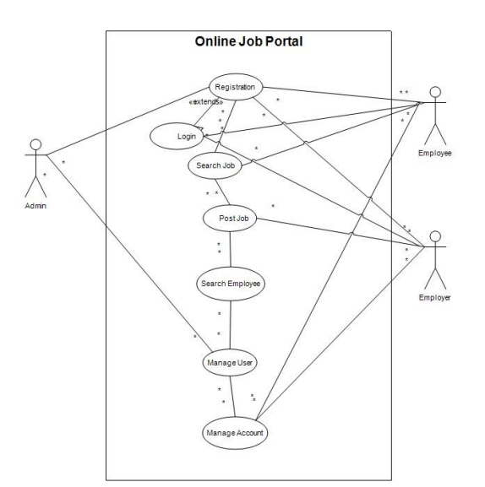
Fig 5.2 use case

5.3 E R Diagram
The Entity-Relationship (ER) diagram for E Career Guidance visually represents the relationships between essential entities like Employers, Job Seekers, and Jobs. It outlines key attributes and connections, providing a structural overview for effective database design and system understanding.

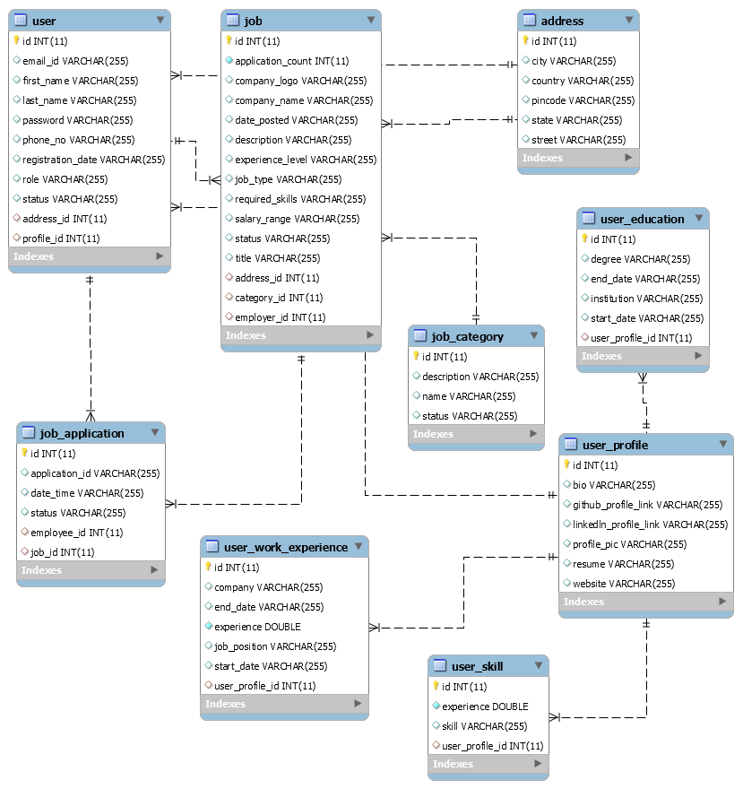
Fig .5.4: ER-Diagram

CHAPTER 6
SYSTEM IMPLEMENTATION

6.1. Implementation
Implementing the E Career Guidance project involves a comprehensive process encompassing software development, database design, testing, deployment, and ongoing maintenance. The following outline delineates the key steps in the implementation journey:

- Software Development:
- Set up a development environment with requisite programming languages, frameworks, and tools.
- Develop a user-friendly and responsive front-end interface for seamless user interaction.
- Implement back-end functionalities, including user management, data processing, and integration of various modules.
- Create specialized modules catering to the Indian farming community, providing crop details, seed information, and crop care solutions.

- Database Design:
  - Use the ER diagram to design the database schema.
  - Choose a database management system (e.g., MySQL, PostgreSQL) and create the necessary tables.

- Testing:
  - Conduct thorough testing to identify and fix any bugs, errors, or security vulnerabilities.
  - Perform acceptance testing to ensure the system meets specified requirements.

- Deployment:

  - Prepare the system for deployment on the production server.
  - Configure the server environment to support the application and database requirements.
  - Implement necessary security measures, such as firewalls and SSL certificates, to protect user data during transmission.

- Monitoring and Maintenance :

  - Implement monitoring tools to track application performance.
  - Create user documentation, including user guides and FAQs, to support users in using the platform effectively.
  - Regularly update and maintain the system to address security vulnerabilities and introduce new features.

- Data Migration:

  - If replacing an existing system, ensure a smooth data migration process to transfer data seamlessly.
  - Validate data integrity and accuracy after migration.

- Monitoring and Maintenance:

  - Implement monitoring tools to track system performance, user activity, and potential issues.
  - Regularly update the system to address bug fixes, security updates, and feature enhancements.

- User Support:

  - Set up a support system to address user inquiries, technical issues, and feedback promptly.

- Rollout and Marketing:
- Launch the system to the target user base, providing valuable job-seeking solutions.
- Implement marketing strategies to enhance awareness and adoption of the E Career Guidance platform.

By meticulously following these steps and fostering effective collaboration among the development team and stakeholders, the E Career Guidance project's implementation can successfully enhance the job-seeking experience for users.

6.2 Screen Shots

Below is the Home Page of our E Career Guidance Application.

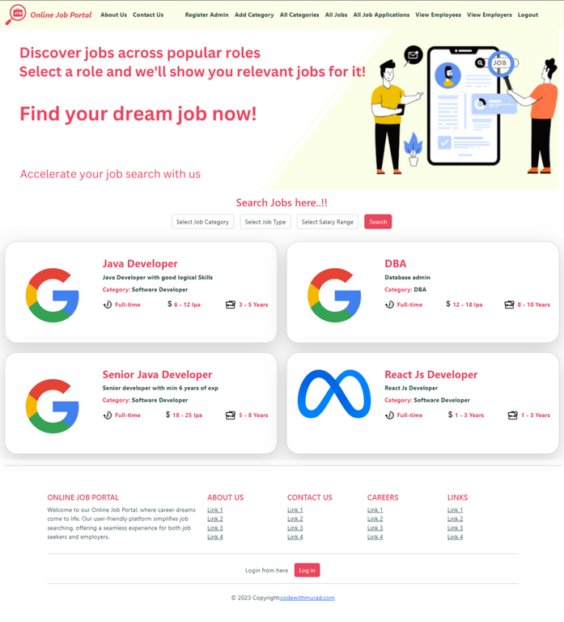

Figure 6.1:Home page

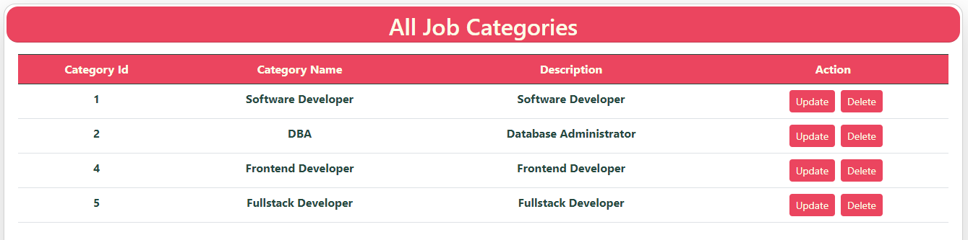
Figure 6.2 Job Categories page

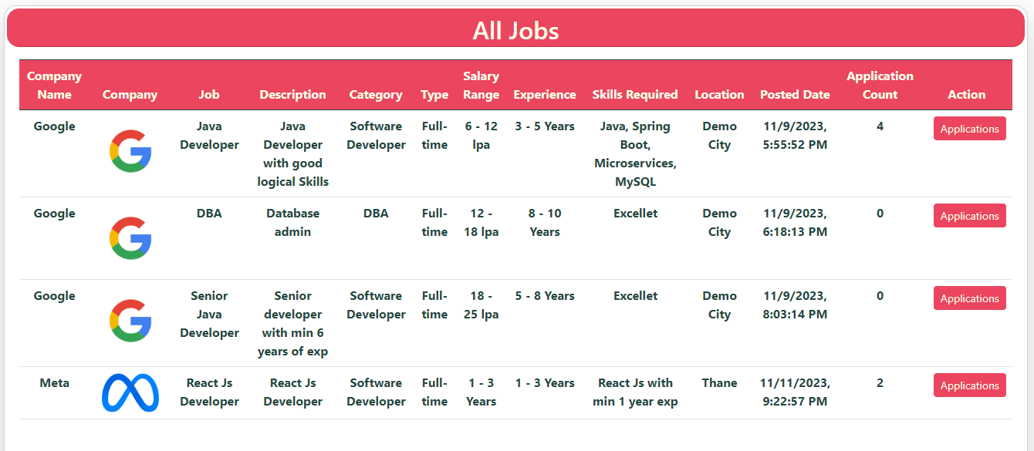
Figure 6.3 All Jobs Posted

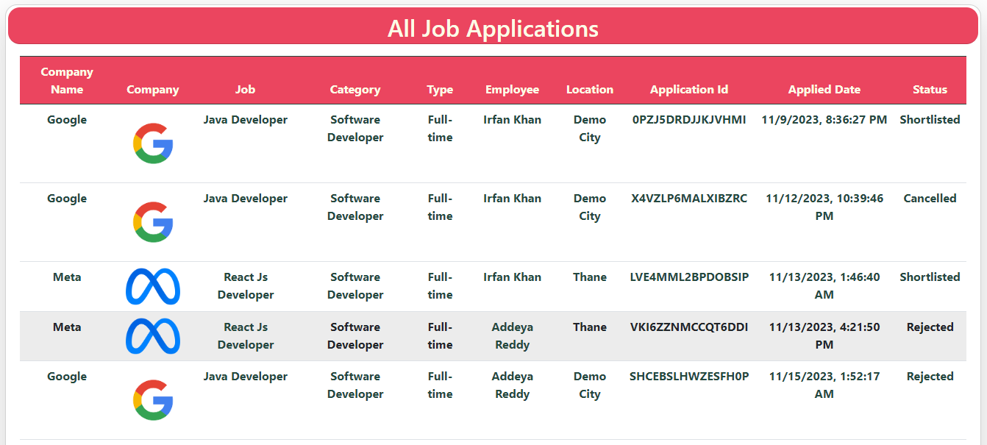
Figure 6.4 All Job Applications

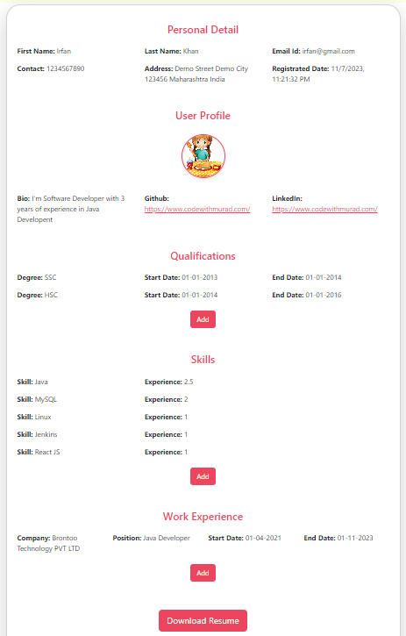

Figure 6.5 Job Seeker Profile Page
.

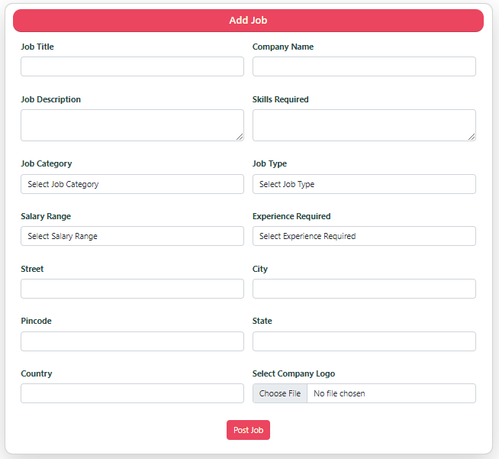
Figure 6.6 Add Job Page

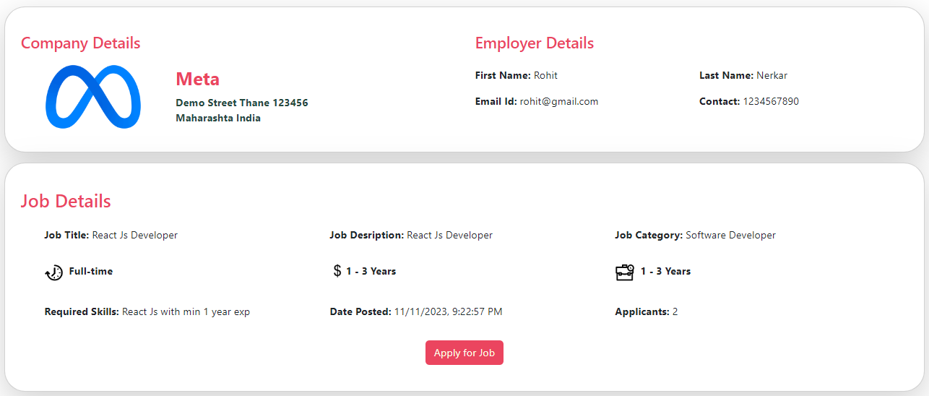
Figure 6.7 Posted Job Detail

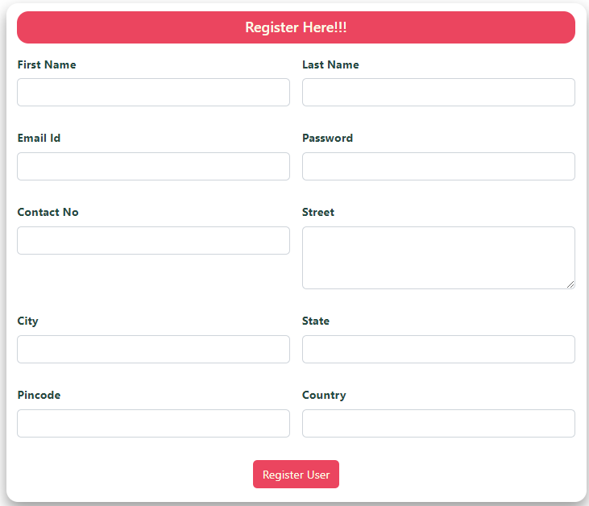
Figure 6.8 Job Seeker Register Page

CHAPTER 7
SYSTEM TESTING
7.1 Test Cases
The testing process is pivotal for E Career Guidance, ensuring software reliability by systematically identifying potential errors. Utilizing carefully curated data sets during maintenance, the goal is to validate program functionality and bring to light any undiscovered bugs. Emphasizing the investigation phase, the primary objective is to uncover errors, marking a successful test as one that reveals previously unknown bugs. Execution of the testing procedure is geared towards discovering defects, not only showcasing the program's purpose but also ensuring the system functions as intended.
The overarching objective is to elevate the quality and reliability of the E Career Guidance platform. This thorough testing approach aims to provide users seeking job opportunities with a seamless and error-free experience, solidifying the platform's dependability in facilitating successful job searches.
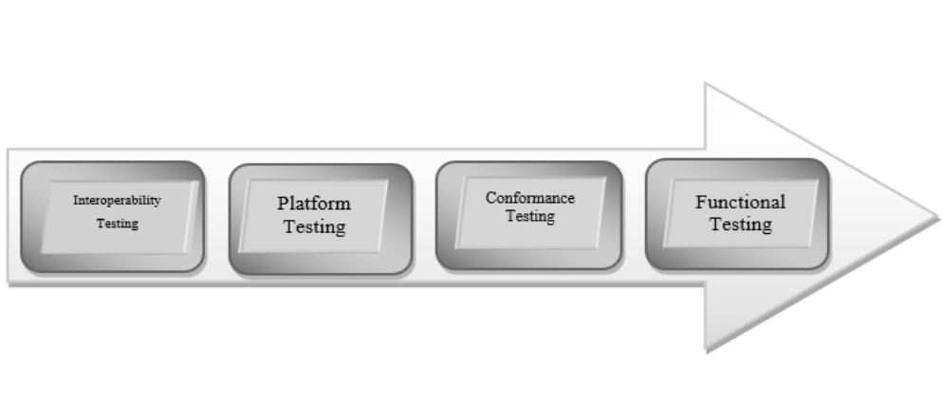
Fig 7.1 : Test Cases Types

7.2 Unit Testing
Unit testing in the E Career Guidance project is foundational, focusing on validating the correctness and functionality of individual units or components in isolation. Each unit, be it a function, method, or procedure, undergoes independent testing, ensuring it works as intended. Key aspects of unit testing include:
- Characteristics of Unit Testing:
  - Isolation: Each unit is tested independently of other units and external dependencies.
  - Automated: Unit tests are often automated, enabling frequent execution and faster feedback during development.
  - Fast Execution: Unit tests are designed to execute quickly, allowing developers to run them frequently and identify issues promptly.
- Purpose of Unit Testing:
  - To validate that individual units of code function correctly and produce the expected outputs for given inputs.
  - To identify defects or errors early in the development process, making debugging more manageable.
  - To provide a safety net for code changes, during further development.
- Writing Unit Tests:
  - Test Cases: Developers write test cases for each unit to cover various scenarios, including normal inputs, boundary conditions, and error handling.
  - Test Frameworks: Unit tests are implemented using testing frameworks specific to the programming language, such as JUnit for Java or test for Python.
- Mocking and Stubs:
  - To isolate units from external dependencies, developers use mocking or stubbing techniques to simulate interactions with other components.
- Test Coverage:
  - Test coverage measures the extent to which the code is tested by unit tests. High test coverage indicates that most parts of the code are exercised by the tests.
7.3 Validation Testing
Validation testing in E Career Guidance is a pivotal step, evaluating whether the final software product aligns with intended requirements and satisfies user needs. Key aspects of validation testing include:
- Objectives of Validation Testing:

  - To ensure that the software fulfils all the specified requirements as documented in the project's requirements specifications.
  - To validate that the software meets the user's expectations and business needs.
  - To verify that the software aligns with the project's goals and objectives.
- Scope of Validation Testing:

  - Validation testing typically occurs towards the end of the software development life cycle, once the system has undergone all necessary development and testing phases.
  - It focuses on the software's behaviour from a user's perspective, emphasizing user interactions and user scenarios.
- User Involvement:

  - End-users or representatives from the client's side are actively involved in the validation testing process.
  - Users perform real-life scenarios to ensure the software meets their requirements and is fit for their intended use.
- Types of Validation Testing:

  - Alpha Testing: Performed by the internal development team in a controlled environment to ensure that the software meets the desired functionality.
  - Beta Testing: Conducted by a selected group of external users in a real-world environment to gather feedback and identify any remaining issues.

- Validation Test Cases:

  - Test cases are prepared based on user requirements and user stories to validate the software's features and functionalities.
  - The focus is on validating end-to-end user scenarios and workflows.
- Defect Reporting and Feedback:

  - If any issues or defects are identified during validation testing, they are reported back to the development team for resolution.
  - Users provide feedback on their experience with the software, helping the development team make necessary improvements.
- Sign-off and Go/No-Go Decision:

  - After successful completion of validation testing, stakeholders may provide a formal sign-off, indicating their acceptance of the software.
  - Based on the results of validation testing, a go/no-go decision is made whether the software is ready for production release.
- Iterative Process:

  - Validation testing can be an iterative process, allowing users to retest the software after defects are fixed or improvements are implemented.

CHAPTER 8
RESULTS AND DISCUSSION

8.1 Conclusion
In conclusion, the E Career Guidance project stands as a testament to innovation and efficiency in the realm of online job portals. With a robust architecture blending Spring Boot and React JS, the platform seamlessly connects employers and job seekers, fostering a dynamic and user-friendly ecosystem.

The project's multi-module approach caters to the diverse needs of employers, allowing them to post jobs effortlessly, manage applications, and streamline the hiring process. On the other side, job seekers benefit from a feature-rich interface where they can create detailed profiles, apply to multiple jobs, and track their application status.

The administrator's oversight ensures the smooth functioning of the entire system, providing valuable insights into job postings, user data, and overall platform performance.

The implementation of fundamental software engineering principles, such as unit testing and validation testing, enhances the reliability and quality of the E Career Guidance platform. Through meticulous testing and iterative development, the project maintains a commitment to delivering a seamless, error-free experience for users.

As technology continues to reshape the job market, E Career Guidance emerges as a beacon of connectivity, bridging the gap between employers and job seekers. The project's success lies not only in its technical prowess but also in its ability to empower individuals in their career pursuits. With a user-centric design, comprehensive functionality, and a commitment to continuous improvement, E Career Guidance embodies the future of online job portals, poised to make a lasting impact in the realm of employment facilitation.

8.2 Future Enhancements
In the relentless pursuit of innovation, E Career Guidance envisions a future marked by strategic enhancements that transcend the conventional boundaries of online job portals. Anchored in user-centricity, the platform's evolution will be characterized by advanced interactivity, featuring personalized user accounts and intelligent chatbots. These elements promise to revolutionize user engagement, providing tailored experiences and real-time assistance. Simultaneously, E Career Guidance seeks to diversify its content, transforming into a dynamic knowledge hub with industry insights and success stories. The integration of e-commerce functionalities is poised to streamline transactions, offering premium job listings and additional services with seamless efficiency. A data-driven approach, supported by enhanced analytics tools, will provide invaluable insights into user behavior, guiding continuous optimizations. Recognizing the global nature of employment, multilingual support is slated to break language barriers, ensuring accessibility for a diverse audience. E Career Guidance also explores emerging technologies like augmented reality for a futuristic touch. Holistic improvements, including enhanced accessibility, social media integration, and robust cybersecurity, underscore the platform's commitment to reliability. Finally, the contemplation of a dedicated mobile app signifies adaptability to evolving digital trends. This strategic roadmap positions E Career Guidance at the forefront of online job portals, promising a future where innovation, inclusivity, and seamless user experiences converge to redefine the dynamics of digital employment platforms.

CHAPTER 9
REFERENCES
References:
[1] Literature review on online job portal
https://ijarcce.com/upload/2017/may-17/IJARCCE%2019.pdf
[2] https://www.naukri.com/account/register/basicdetails
[3] https://corp.freshersworld.com/post-job?src=homeheader
[4] https://www.freshersworld.com/

